
Year 5 Term 1 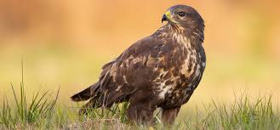

Class5@Luddenham.kent.sch.uk 01795 532061 Term 1

Learning Overview
English  (Reading and Writing) | Handwriting/ Spelling | Maths | Other Learning
This term we will be reading:  - Holes by Louis Sacher  We will be providing opportunties to write by  - Non Chronological Report  - Biography  - Narrative- Setting | - Handwriting will be focussing on using ladder letters.  - We will also be looking at spelling of homophones and key words from last year. | This term in maths we will focus on:  - Place value  - Addition and Subtraction  - We will also be recapping our times tables and developing our recall speed. | We will be looking at the Vikings in History.  In Science we are learning about Materials, mixtures and seperation.  Our PSHE will be looing at ‘My healthy self’.  In PE we have Tag Rugby and Gym.
How can you help at home?

P.E Days this term
Don’t forget to wear your P.E. Kit on…
Tuesday for Gym and Friday for Tag Rugby

Home Learning Expectations
Try to encourage your child to record their reading in their reading record each time they read. We will be checking them every Thursday morning. Also please encourage them to practise their spellings for a spelling quiz each Friday. Also plenty of Times Table/TTRockstars practice where possible.

Key Dates for Year 5
Thursday 3rd September – Start of Term 1- Children back
18th September – 2.45 p.m - Meet the teachers
Friday 2nd October- Individual School Photos
Friday 16th October- Rangers Day
Friday 23rd October – End of Term 1

OTHER INFORMATION
Please feel free to contact us with any questions on the class email account
Class5@Luddenham.kent.sch.uk

